1. **PURPOSE:** This SOP explains the necessary steps for entering human tissue and blood specimen PHI into REDcap database.
2. **SCOPE and RESPONSIBILITIES:**   
   1. Scope:
      1. The activities described in this SOP are to ensure proper handling, data entry and reporting of PHI in REDcap database in accordance with HIPAA regulations.
      2. Based on IRB #08-0338-F2L, PI: Kenneth Campbell.
   2. Responsibilities:
      1. Principal Investigator
      2. Co-Principal Investigator
      3. Research Coordinator
      4. Program Coordinator
      5. Program Fellows
      6. Postdoctoral Researchers
      7. Graduate Students
      8. Undergraduate Students
3. **DEFINITIONS and ABBREVIATIONS:**
   1. Definitions:

* Hashcodes - used to identify sample without providing any patient information.
* Procurement - the action of obtaining or procuring something.
  1. Abbreviations:
* AEHR – Allscripts electronic health record (database)
* HIPAA – Health Insurance Portability and Accountability Act
* IRB – Institutional review board
* SCM – Sunrise clinical manager (database)

1. **SAFETY AND QUALITY CONTROL:**
   1. Follow HIPAA regulations when entering data into REDcap.
2. **MATERIALS and EQUIPMENT:**

Various materials and equipment may be required for data entry in REDcap. Generalized items may include, but are not limited to,

* Computer
* REDcap
* PHI
* SCM
* AEHR

1. **PROCEDURE:**
   1. To gain appropriate access to be a part of data entry in REDcap, contact the Biorepository Program Coordinator.
   2. Have the hashcode envelope containing notecard with patient sticker.
   3. Go to <https://redcap.uky.edu/redcap/index.php>. Enter username and password.
   4. Click the “My Projects” tab. Select Cardiac tissue – clinical data.

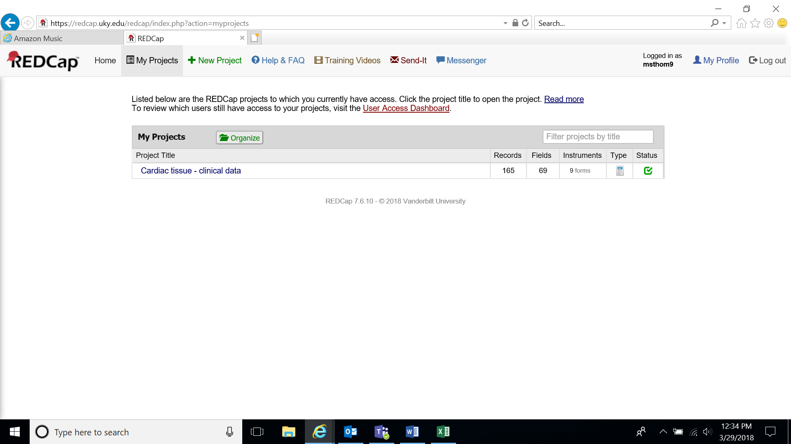

* 1. Click add/edit records.

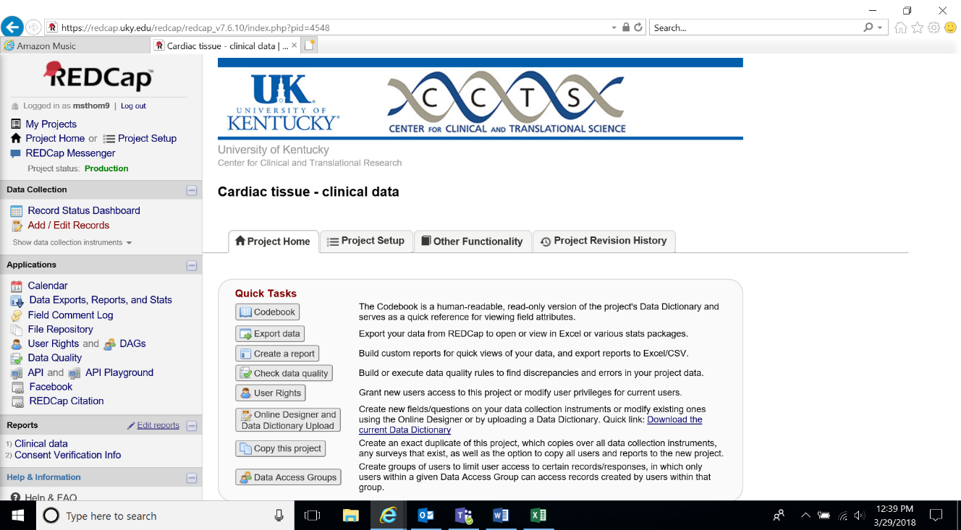

* 1. Enter hashcode in enter a new or existing Record ID.

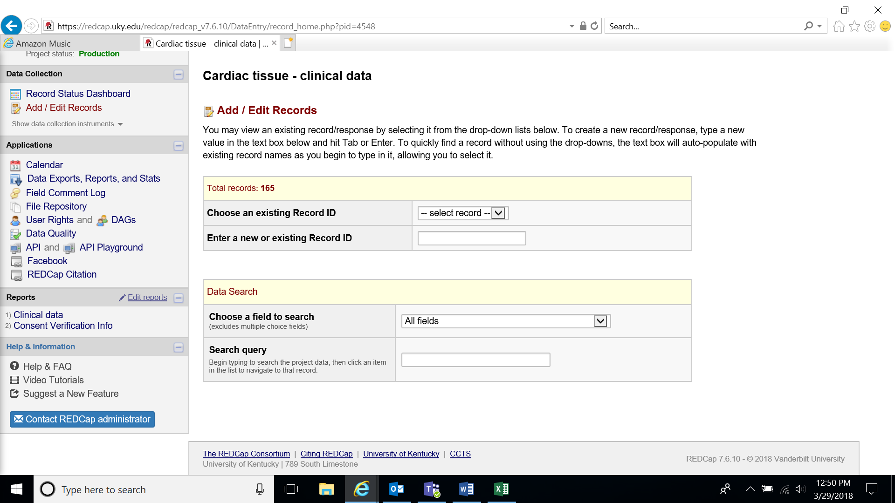

* 1. Click on each circle to fill in information. You can also edit information by selecting a category.

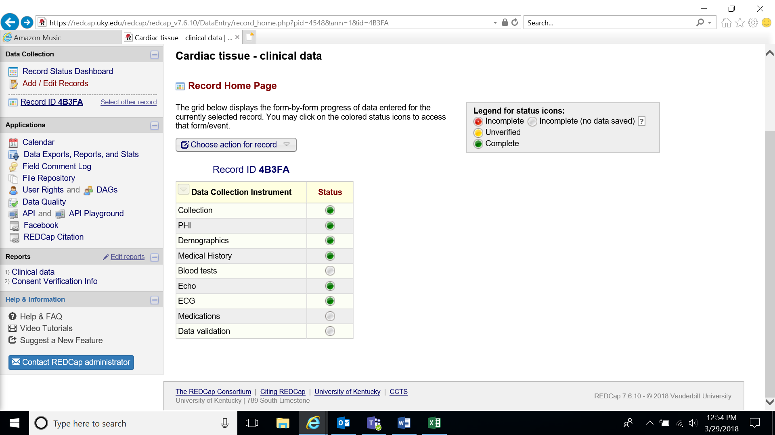

* 1. Under the collection tab, it will ask if consent has been checked. Please contact the Program Coordinator, Regulatory Manager, or Clinical Research Director to ensure this has been checked before selected the completed option under this tab.
  2. PHI, demographics, medical history, blood tests, Echo, ECG, and medications data can be found in SCM or AEHR. You want to select the information that is most recent but prior to the specimen collection. SCM and AEHR are most useful for heart transplants and LVAD placement or removal.
  3. UNOS is used to retrieve clinical data for donor specimens.
  4. There are situations, especially with organ donor samples, that we cannot recover all desired data. Obtain as much information as you can. If no further data can be collected for that category, complete the record.

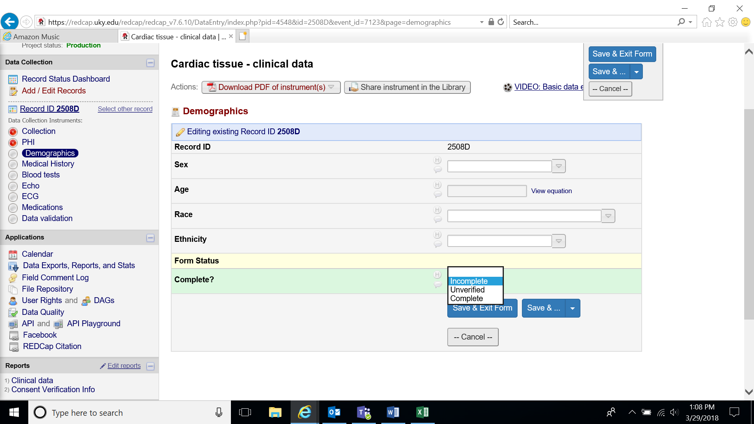

* 1. After all information has been entered, discard the envelope and notecard containing PHI in a confidential recycling bin.
  2. Follow HIPAA regulations when handling PHI.
  3. Always log out of database. Never share you login information.